Readme

The Virtual Scene is a Bedroom, consisting of a Bed, a Study Table, a Study Chair, a Study Lamp, Coffee Mug, Laptop, Printer, a ceiling fan, a Clock, some paintings, a Cabinet.

The 3D Manipulation Technique used is a Virtual Hand, and has four states using the hand.ongoingTrigger and button.getPressed,

If (!button.getPress()), the Virtual hand will be in Open state,

If(button.getPress() && !hand.ongoingTrigger()), the Virtual hand is in Closed State,

If(hand.ongoingTrigger()) the hand will be in Touching state, and

If(button.getPress() && hand.ongoingTrigger()) the hand would grasp the object it is touching.

The user can then simply perform other manipulations like rotating the object by simply twisting the handheld controller, or move the object

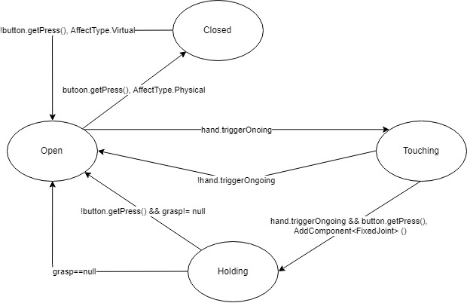

The following objects in the scene have the interactive script

Chair,

Printer

Light

Laptop

Mug

The following objects have Stationary Script

The Desk,

Bed,

Bed Room

Fan

The 3D travel technique implemented uses the comparison of absolute values of x, and y to determine to either go forward or backward or go sideways left or right.

The following are used,

When button is pressed &

If |x| > |y| & x < 0, we steer towards left

If |x| > |y| & x > 0, we steer towards right

If |x| < |y| & y > 0, we steer forward

If |x| < |y| & y < 0, we steer backward

And if !buttonPressed, we don’t Steer

Figure 1: The following figure consists of the five states used in the 3D Travel Technique, and the inputs they take

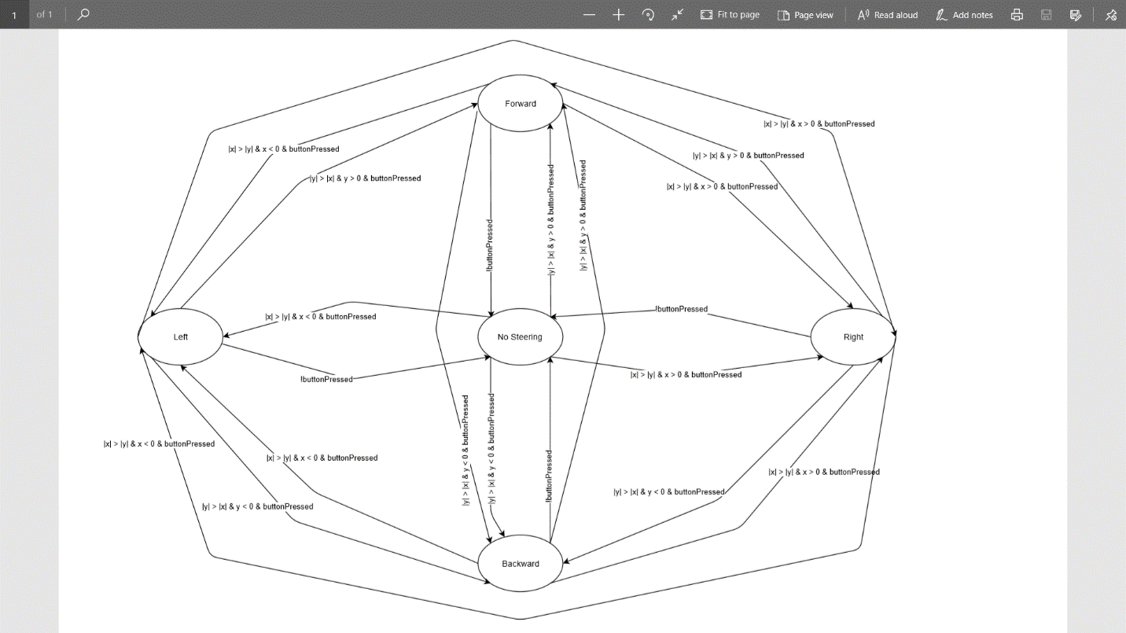

The following objects in the scene consists of 3D sounds:

Ceiling fan (on loop)

Clock (on loop)

Air Vent (AC/Heater) (on loop)

Laptop fan (on loop)

Printer (Starts with a delay of 3s, and plays once)

Please navigate to:

~\3D Virtual Environment\Assets\Scenes\SampleScene.unity

And open the SampleScene.unity file in unity.